Shock Test Results for CAM 2 :-  
  
These tests are done for 3 kind of defects in Cam 2 images:-

1. Short Mitre - defective or non_defective ( 2 classes)
2. Long_Mitre - defective or non_defective ( 2 classes)
3. Top Lid – defective or non_defective ( 2 classes)

All files of shock test are available here in zip format

1. SHORT MITRE

Defective Predicted were 62 items

Correctly defective predicted 53 Reverse Packet 1 False Detection 8

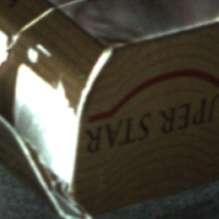  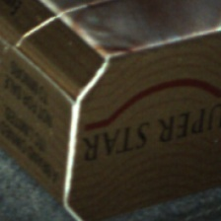

Non_defective predicted 44 items

Correctly predicted 34 Blanks 3 Escape 7

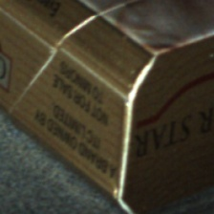 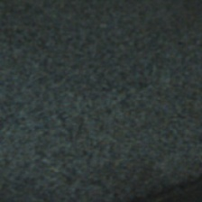 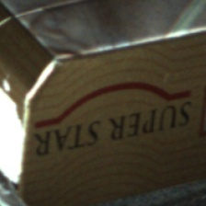  
  
  
  
  
  
  
B) LONG_MITRE

Main reason for false detection and escapes was inefficient bounding box of image(defect not checked in image captured) , will resolve that

Defective Predicted (82 items)

Correct long seam open 68 False Detection 14  
 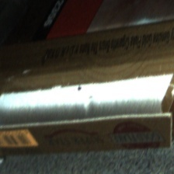 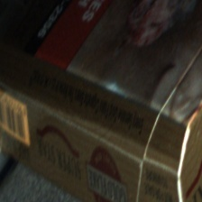

False detection no will go down with increased dataset of training

Non_defective predicted 88

Correctly predicted 86 Capturing error 1 Reverse Packet

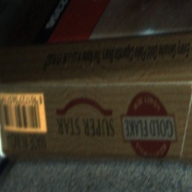     
  
  
c) TOP LID

Top lid defected predicted 82

Mild defective 55 Severely Damaged 21

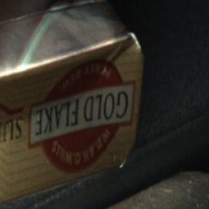 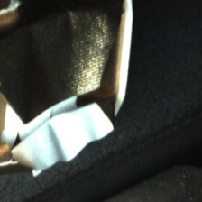

Capturing error 1 False Detection 5  
  
 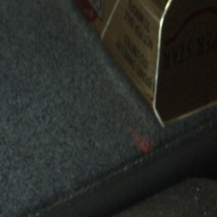 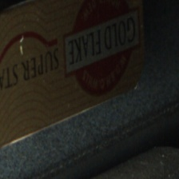  
  
Undefective predicted 14

All were correctly predicted